Q1. Explain Class and Object in java programming?

Ans:

**Purpose:** It is used to create a user defined data type in java programming

**Definition:** Class is the collection of member data and member function

Class is a set of rules

**Member Data:** Member data can specify what type data can be occur

**Member Function:** Member function can act mediator between user and data.

Syntax:

class ClassName{

//member data

//Member function

}

How to create object of a class

ClassName objName=new ClassName();

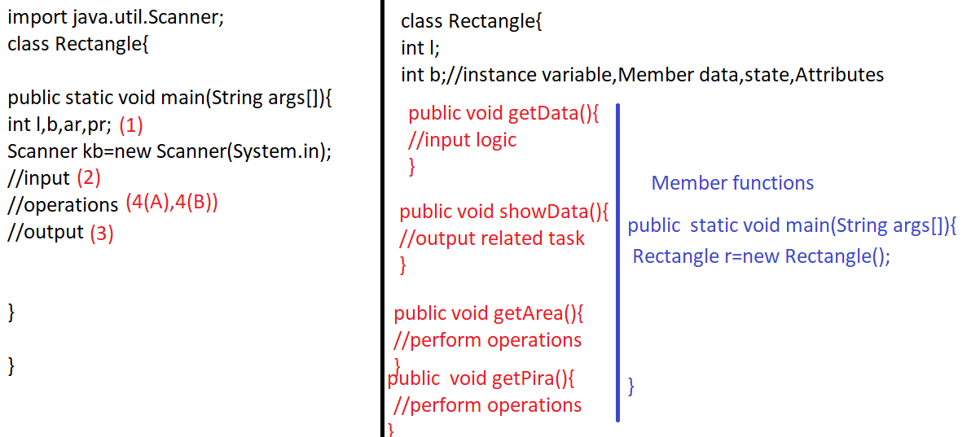

How to call methods of a class

objName.methodName();

